 | Email your order form to denthecaver@yahoo.co.uk  Or post to: D Jump,  1 Gelsmoor Road,  Coleorton, Leics.  LE67 8JF
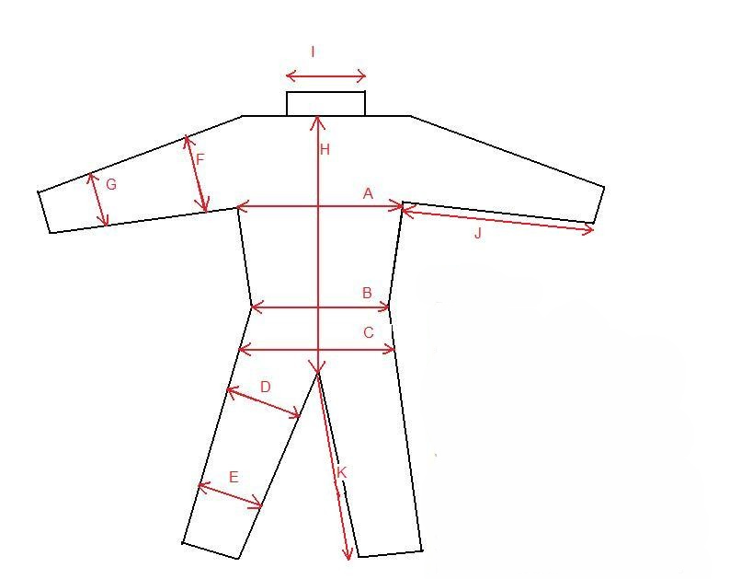 | How to take your measurements  All measurements are best taken off an old undersuit that you know fits, especially the back measurements as you need to allow room to bend. Measurements in either inches or centimetres are accepted, please be consistent throughout and state which to avoid confusion.  A Chest…………………………..  B Waist…………………………..  C Hips……………………………  D Upper leg (width flat)  ……………………………………  E Lower leg (width flat)  ……………………………………  F Upper arm (width flat)  ……………………………………  G Lower arm (width flat)  ……………………………………  H Base of collar, down back to crotch (allow room to bend)  ……………………………………  I Neck width……………………..  J Inside arm……………………..  K Inside leg……………………...
Material (Tick your choice)   Polarfleece   Polartec 200   Powerstretch (Lightweight)   Powerstretch (Heavyweight) | Your chosen fleece colour (Please note some colours will not be available)  …………………………………….
Adjustments/special requests required:  (Tick your preference)   No   Yes (Describe below)  ………………………………………………..  ………………………………………………..  ………………………………………………..  ……………………………………………….. | Your contact details:  Name:  Address:  Email:  Phone:

